**Problem 1**

1-P

A-P

1

2

2-P

3

4

**A**

**P**

3

4

1

2

3-P

4 x 15 = 60 mm

**Problem 2**

**45 mm**

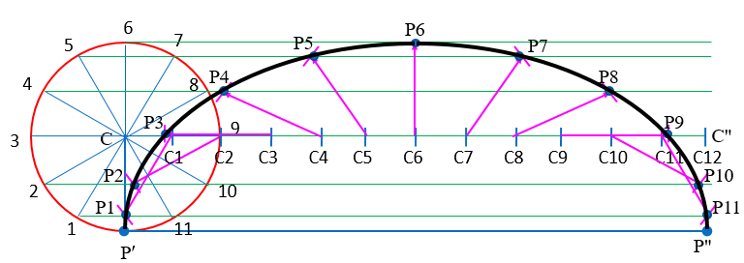

45π ≈ 141.4 mm

**Problem 3**

VF = 30 mm

e = 0.5

⸫ VF / CV = 0.5

=> CV = 30 / 0.5 = 60 mm

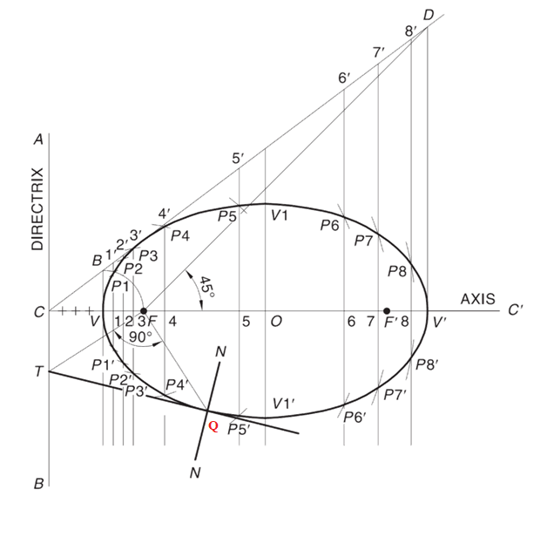

120 mm

30 mm

60 mm

**USE SUITABLE SCALE**

**Problem 4**

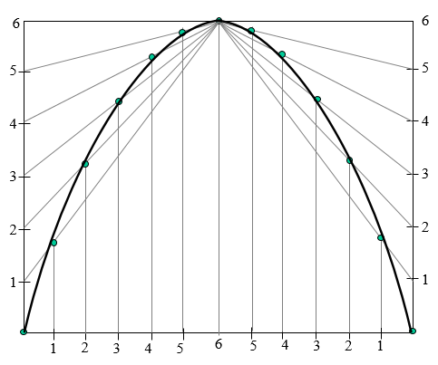

40 mm

60 mm